Here is an example area where we have Class 1, class2, and Class 3 wetlands

Class 1 are light yellow, Class 2 are kind of salmon, and the Class 3 are reddish.

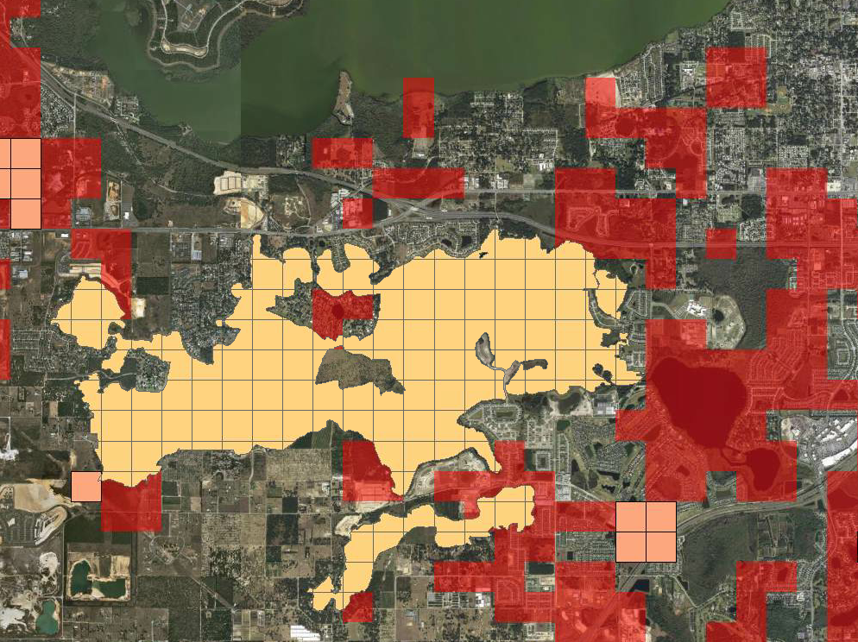

The pale blue transparent cells are Lakes modeled with the River package with proscribed heads.

So Class 1 wetland (John’s Lake) will not show impacts pro or con. The cells completely cover even wetland edges so wetland margin effects can be captured.

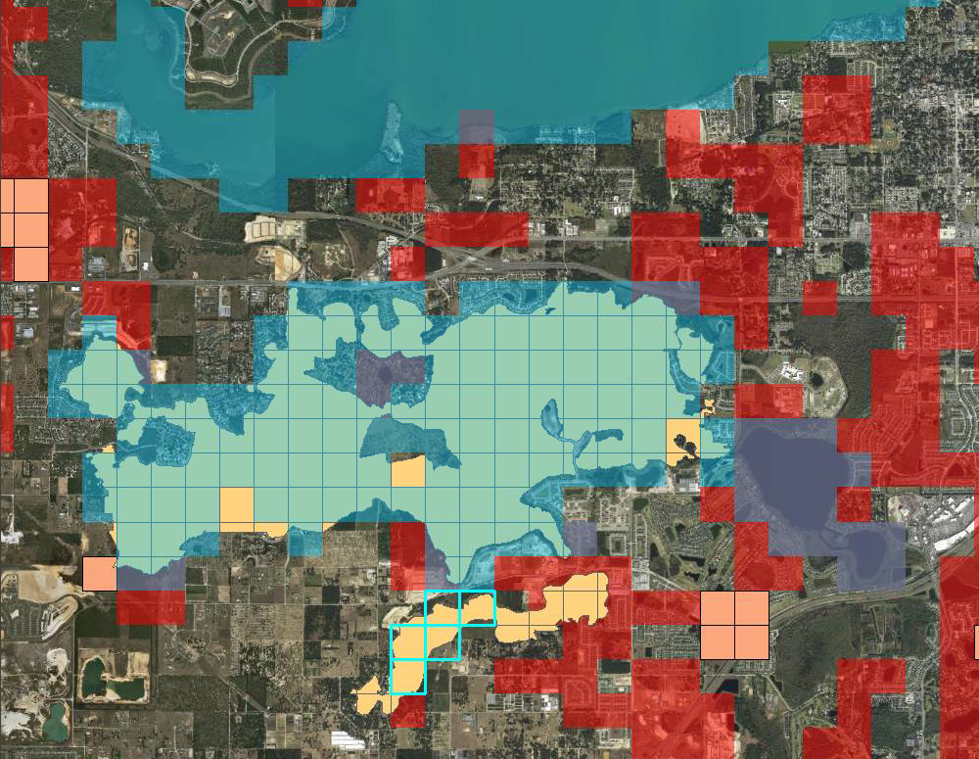

The cyan outlines are High K lake cells, which will have an effect on open water area calculations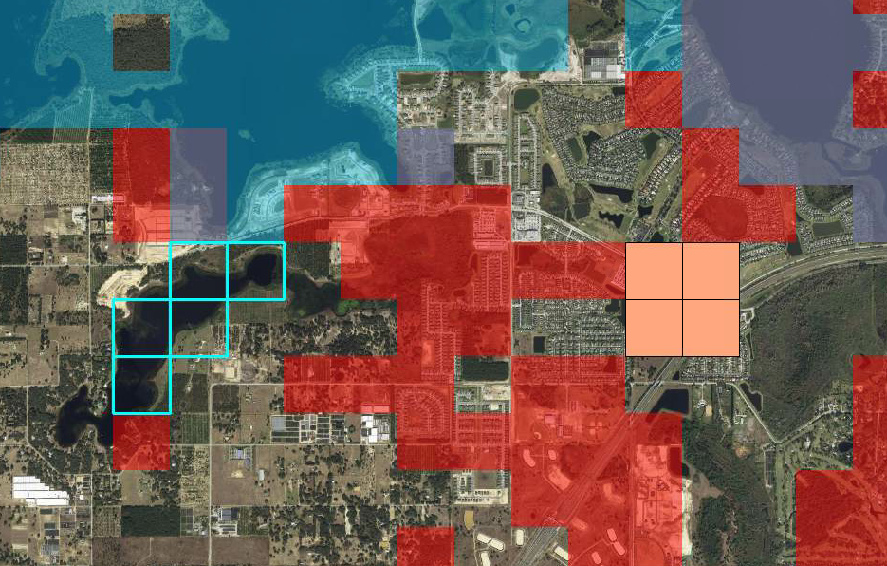

We could subtract the intersected cells in Lake Avalon from the Class 1’s however the rest of the area is also largely open water, which isn’t otherwise identified as a class3 wetland

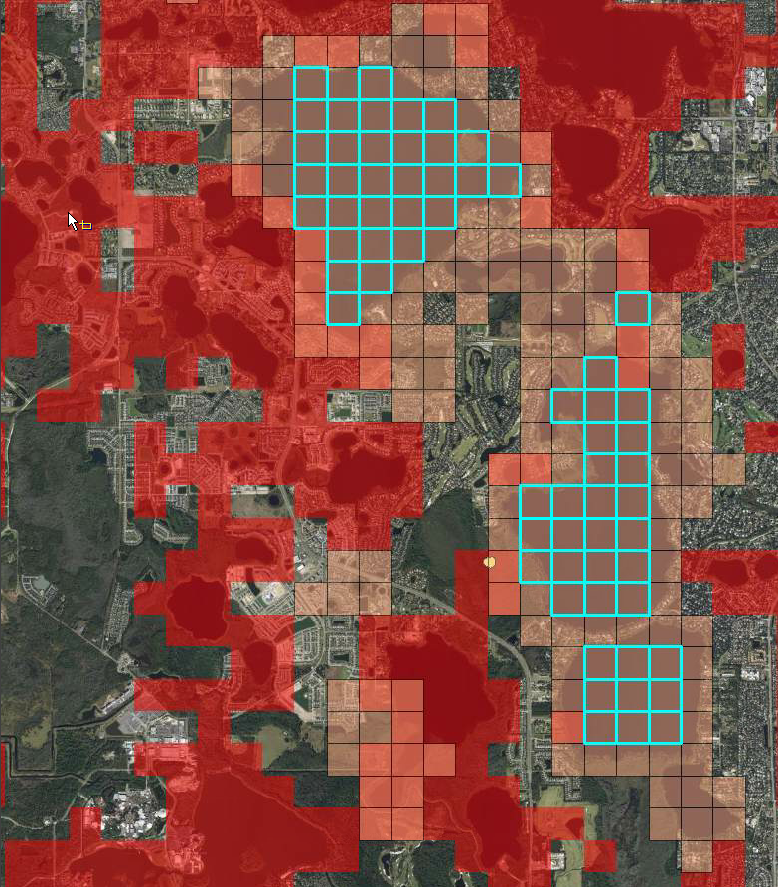My original thought was many of the wetlands would look like these. Showing wetland cells with areas covering as well as surrounding the lakes. These cyan cells show class 2 wetland where their acres identify the entire cell. But adding the River cells to the map shows most of the class 2 cells will have controlled heads.

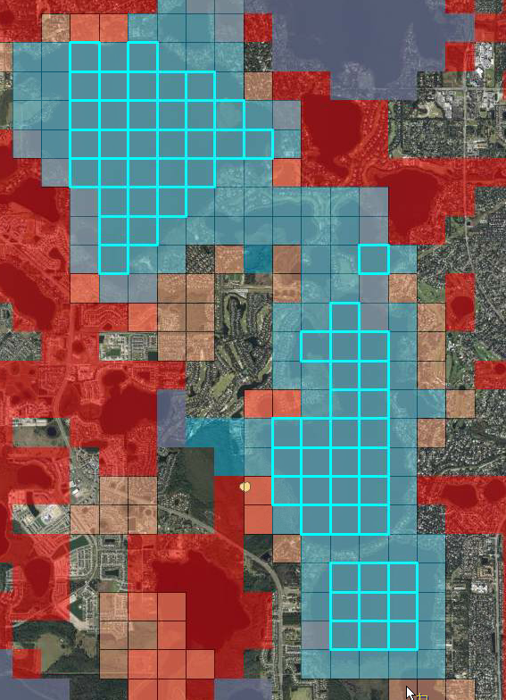

Most but not all of the High K lakes fall in SWFWMD

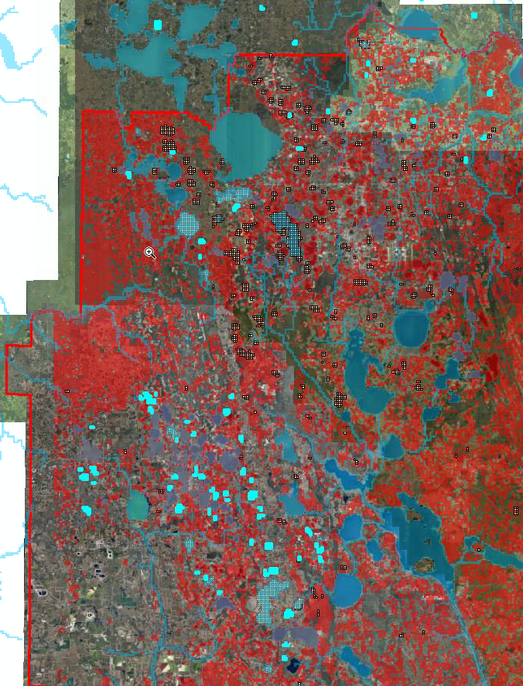d

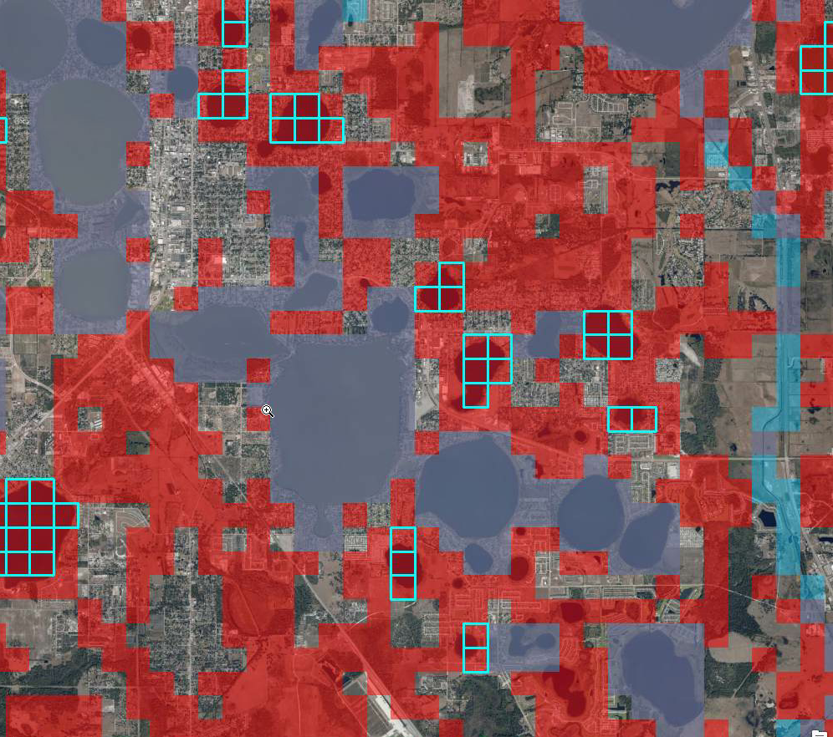

The purple areas show where the model cells are River cells with controlled elevations. The cyan areas show quite a bit of area that are class 3 which does show open water from the aerials, although a large portion is being modeled as if it is open water, which makes it quicker for water to go up and down than in real life.